Stephen L. Hadden
Senior Pastor Candidate
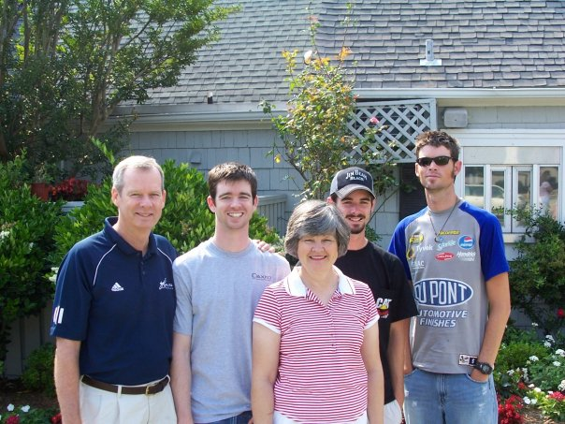
Steve Hadden is a native of Elizabethtown, Kentucky. Steve completed two years of pre-pharmacy school at Georgetown College and holds a Bachelor of Science degree in pharmacy from Mercer University in Georgia. He completed Master of Divinity and Doctor of Ministry degrees at Southern Baptist Theological Seminary in Louisville.
Steve has served as Senior Pastor for churches in Kentucky, Florida, and South Carolina. Additionally, he currently serves as an Assistant to the Presidents at the Baptist Seminary of Kentucky and Georgetown College. Steve continues to hold licensure as a Registered Pharmacist in Kentucky.
Steve loves sports including basketball, baseball, tennis, football, and golf. He is a HUGE UK fan! (Just ask Clark Bugg, who recently enjoyed a night at Rupp Arena with Steve.)
Steve is married to Joy who is described by Steve as, "my right arm for many areas of ministry." Joy is a realtor and a decorator who enjoys making their home a welcoming place for guests. Joy LOVES gardening, canning and cooking new recipes as well as some of Steve's old favorites, cornbread! Being a new grandma is Joy's favorite role these days.
Steve and Joy have three sons: Tommy, Jon, and Jordan. Tommy is married to Susan and they are parents to Steve and Joy's only grandchild, Kiera. They live in Louisville where Tommy has his own reconstruction and renovation business. Susan is a musician who leads in worship at Calvin Presbyterian Church and teaches piano lessons at two churches and at home.
Jon is married to Bethany, and the couple resides in Charlotte. He is employed by UNC Charlotte (but he will never cheer for the "lighter" blue!). His wife is employed as graphic artist and paints for a local gallery. Jon also is trained in Arabic and is currently serving in the National Guard.
Jordan is single and lives in Louisville. He currently works with his brother, Tommy, in the construction business.

